Cook Islands Reporting Tool
Exercise 1: Defining Indicators (Indicator Definitions);
Indicator Name | Turtle movement and nesting
Definition | Sea turtles’ distributional range
Desired Outcome | determine the species range of sea turtles that are present in Cook Island waters. Assimilating all available information on the distribution of sea turtles at breeding, foraging, developmental sites and how these areas are connected to understand the distribution patterns of sea turtles at the size class, population and species level to select key areas for protection
Measurement or Calculation | ratio (female seen once)/(total number of females) for each beach
Unit of measurement | #
Rationale and Assumptions
Preferred Data Source | Cooks Islands National Environment Service

Indicator Name | Physical climate and climate trends
Definition | state of various climate parameters including temperature, rainfall, cyclone frequency and waves and future projections
Desired Outcome | Cook Islands taking climate change preparations and impacts seriously. Programmes to address the issue include data collection to improve weather forecasting and enable advance climate and disaster preparedness, tide gauge upgrades, collection of local, traditional knowledge on climate and weather predictions, and better collation and dissemination of information about its physical climate and climate change.
Measurement or Calculation
Unit of measurement | °C (temperature)/ mm (rainfall)
Rationale and Assumptions
Preferred Data Source | Cooks Islands National Environment Service

Indicator Name | Historical and Marae sites status and protection
Definition | the state of historical and Marae sites and measures cultural landscapes formed through interaction between culture and environment, or by Cook Islands imposition of traditional meanings onto the environment
Desired Outcome | strengthened the importance of these places, and protect them in the face of changing cultural attitudes, and threats and pressures from increasing  development.
Measurement or Calculation | Total number of identified historical sites
Unit of measurement | Number
Rationale and Assumptions
Preferred Data Source

Exercise 2: Reporting Obligations
- Manage Reporting Obligation
Next to Aichi Obligation – Click “Manage Framework”
Add the following Targets by clicking “Create New Target”;
Aichi Target 1 By 2020, at the latest, people are aware of the values of biodiversity and the steps they can take to conserve and use it sustainably.

Aichi Target 2 By 2020, at the latest, biodiversity values have been integrated into national and local development and poverty reduction strategies and planning processes and are being incorporated into national accounting, as appropriate, and reporting systems

Aichi Target 3 By 2020, at the latest, incentives, including subsidies, harmful to biodiversity are eliminated, phased out or reformed in order to minimize or avoid negative impacts, and positive incentives for the conservation and sustainable use of biodiversity are developed and applied, consistent and in harmony with the Convention and other relevant international obligations, taking into account national socio economic conditions.

Aichi Target 4 By 2020, at the latest, Governments, business and stakeholders at all levels have taken steps to achieve or have implemented plans for sustainable production and consumption and have kept the impacts of use of natural resources well within safe ecological limits.

Aichi Target 5 By 2020, the rate of loss of all-natural habitats, including forests, is at least halved and where feasible brought close to zero, and degradation and fragmentation is significantly reduced.

Exercise 3 : Update Indicator State (click on Update Indicator States, select one of the following indicators from the list and update with the information provided)
- Indicator: Renewable Energy
Step 2 Narrative
In Cook Islands and across much of the Pacific, energy is a serious and growing problem. The country’s small size and relative isolation makes it challenging to access cheap energy for all citizens, and most islands are highly dependent on fossil fuels for their energy needs, including electricity and transport. These islands are extremely vulnerable to fluctuating world fossil fuel prices.

Cook Islands also has some of the highest per capita energy consumption in the Pacific, at about 1800 KWh per person as of 2013. The high proportion of tourism and energy using facilities, the high access to energy across the islands, a rise in household incomes and more electrical products such as white goods, computers, phones and power tools all account for this high per capita national energy consumption.

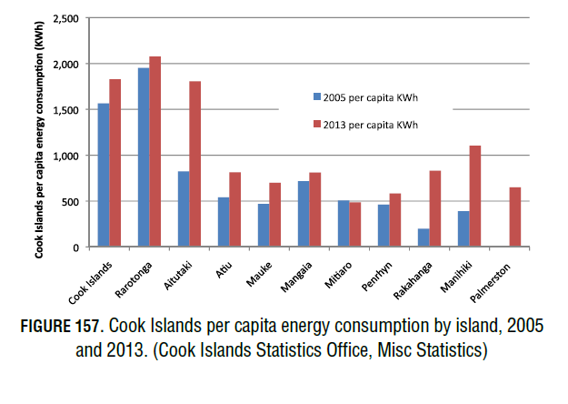

Step 3 Impact

Access to energy has traditionally been a key factor in improving health, education and quality of life in developing countries. Energy development and energy access for vulnerable, isolated populations such as the Pa Enua has immediate benefits, such as refrigeration for medicines and foods. However, in areas like Rarotonga that already have high levels of energy access, more access has drawbacks and creates further pressures on the environment, society and economy. These include a rise in sedentary lifestyles, a loss of cultural activities and more use of energy consumptive products. This raises the demand for more energy, produces more waste and increases household energy expenditures.

STEP 4 Response & Recommendations

Cook Islands has greatly increased the solar panel installations. The government target is to be 100% renewable electricity by 2020. Nevertheless, energy consumption campaigns should be promoted as the higher energy consumption may not be sustainable, even if it is sourced from solar panels.

Step 5 Key Finding

Most islands depend on imports of fossil fuel. Cook Islands has a very high energy consumption per capita, partly due to high numbers of tourists and more electrical products. Cook Islands has one of the most efficient electrification systems in the Pacific and plans to greatly expand the renewable energy sector

STEP 6
Status: Good
Trend: Stable
Data Confidence: High
Data as of 2019

Step 7: Sources

Cook Islands National Environment Service https://environment.gov.ck/

- Indicator: Trends in Greenhouse Gas Emissions

Step 2 Narrative
The Cook Islands Second National Communication under the UNFCCC revealed that per capita GHG emissions rose by 56% between 1994 and 2006 (3.6 t CO2 per capita). This largely resulted from the increased availability and use of electricity, higher national consumption of energy-reliant products such as air conditioners, vehicles, white goods and other electronics, and a dramatic increase in tourism. The relative contribution of GHG emissions by sector and the overall trends in GHG emissions from 1994 to 2006 have risen 62% (Figure 46). The energy sector is the biggest contributor to GHG emissions.

Step 3 Impact

With energy production and road transport reliant on fossil fuels, there are several local impacts including reduced air quality from fossil fuel burning and reduced energy security from volatile world
fuel prices and shipping disruptions. Both high and fluctuating fuel prices have a destabilising effect on the local economy and households and limit economic growth, particularly in isolated and vulnerable areas. Fuel shortages for road transport occur from time to time.

Step 4: Response and Recommendation

The Cook Islands’ first National Energy Policy was enacted in 2003. This policy was replaced by the 2009 National Renewable Energy Policy, and again by the 2011 Renewable Energy Chart. The Government policy proposed specific policies, measures and actions in six areas:
1. Harnessing renewable energy;
2. Clean and green transportation;
3. Being energy smart;
4. Having the right infrastructure;
5. Awareness that prompts change; and
6. Building our capacity.

Step 5: Key Finding

Ozone depleting substances (ODS) have been greatly reduced; CFCs phased out in 2010 and HCFCs in
2015.

Step 6:
Status: Fair
Trend: Deteriorating
Data Confidence: High
Data : 2018

Step 7: Sources
- Government of Cook Islands. 2012. Customs Tariff Act 2012.
- Intended Nationally Determined Contributions to the UNCCC fromCook Islands. Submitted 20.11.2015.

- Indicator: Access to quality and sewage treatment

Step 2 Narrative
In the Cook Islands, the major sewage treatment systems are household septic systems (including flush and pour toilets), pit toilets and the rare, traditional lagoon toilet. Management of sewage waste is a major problem, in part, due to limited space, porous soils and heavy rainfall. This quickly flushes contaminants into the environment. These challenges are compounded by scarce
resources to develop an extensive sewage infrastructure, including a lack of compliance and poor enforcement of regulations.
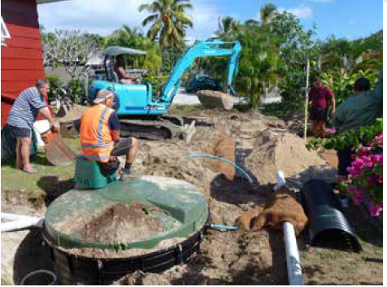

Step 3 Impact
The main impact from poor access to sanitation is health related and includes gastrointestinal diseases and associated serious diseases such as typhoid, dysentery and hepatitis. These have profound impacts on social development, the economy and tourism. In addition, environmental impacts include eutrophication of rivers and marine waters, increased algal growth, smothering of coral reefs and reduced visibility. These affect fish, people’s livelihoods and tourism operators.
Sanitation systems need to be improved but this also means higher maintenance costs. Cook Islands is making great efforts to find which systems are best for different areas as new systems may still result in high nitrate levels

Step 4: Response and Recommendation
Composting toilets are actively promoted by the government. This effort should be continued and
options for commercial level systems should be explored. The sanitation systems of 214 households
were upgraded. In 2014 the Ministry of Health developed sanitation regulations which should be implemented. The recommendation is to monitor and prioritise areas that are major sources for
septic pollution.

Step 5: Key Finding
Septic tanks are the most common sewage treatment system. Almost everyone has access to flush or pour toilets. Pit holes and lagoon toilets are very rarely found in the Pa Enua. Limited space and porous soil combined with heavy rainfall makes sewage management a major problem. Poor access to sanitation causes health problems and has also a negative impact on the environment.

Step 6:
Status: Poor
Trend: Improving
Data Confidence: Medium
Data : 2018

Step 7: Sources
Cook Islands Statistics Office. Ministry of Finance and Economic Management.

Cook Islands Asian Development Bank (ADB). 2009. Final Report TA 7022‐C00: Preparing the Infrastructure Development Project. Volume 3: Water Supply and Sanitation Sector

Cook Islands Statistics Office. Ministry of Finance and Economic Management. Cook Islands

Indicator 4: Land Under Cultivation
Step 2 Narrative
Agricultural activity has dropped sharply in Cook Islands since 1988, particularly subsistence farming. Farming had already slowed from the 1950s through the late 1980s, with the decline of the coconut and citrus industries. Some commercial agricultural activity and export markets of fruits and vegetable grew in the mid-2000s, but have since declined. Figure 83 shows the decline in the amount of land used for agricultural activities in Cook Islands, with the biggest drop in the northern Pa Enua.
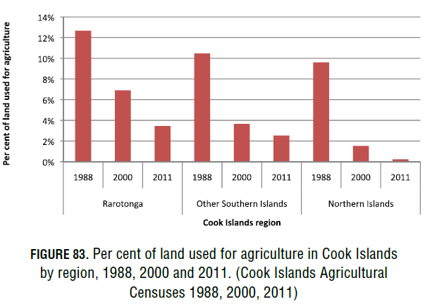
Step 3 Impact
Natural forest cover is important for the preservation of biodiversity in forest habitats, particularly for endemic and native bird species such as the Kākerōri, and a diversity of birds on Atiu . In addition, natural forests provide important ecosystem services and aid in erosion
control, climate moderation, water balance, shelter for native plant and animal species, and as sources of firewood for local communities. It can also provide important natural environments for the development of ecotourism and recreation, especially for activities such as bird watching
and trekking.

Step 4: Response and Recommendation
Cook Islands should continue to support its farmers in order to encourage growth in the agricultural
sector, increase national food security and decrease dependence upon imported foods. Particular emphasis should be placed upon training and development of Cook Islander youth agricultural programmes, especially with most of the country’s farmers currently aged 65 and above. ‘Go
Local’ campaigns, with support for local agricultural development and integration across all sectors would also help to strengthen agricultural development.

Step 5: Key Finding
Agricultural activity has dramatically declined since 1988, especially subsistence agriculture. This reflects the national shift from a resource-based economy to a service-based economy. Most farmers are now aged 65 and above. The declining agricultural activity can result in the
spread of invasive species to fallow lands, more reliance on imported foods, less food security, and
reduced public health.

Step 6:
Status: Fair
Trend: Stable
Data Confidence: Medium

Step 7: Sources
Food and Agriculture Organization of the United Nations. 2010. Global Forest Resource Assessment, Cook Islands.

National Environment Service. 2002. Cook Islands National Biodiversity Strategy and Action Plan (NBSAP).

