SOPAC Technical Report

Niue Coastal Water Quality Survey

Luke Mosley

SOPAC
Date: March 2004

Background

Niue’s surrounding coral reefs and ocean are a very important resource for the country, providing food for the local population and economic benefits from fishing and tourism. Increased development of the coastline and utilisation of coastal resources has caused significant degradation of reef habitats and a loss of species diversity in other reef locations (Hodgson, 1999). These impacts have been observed as the result of factors such as increased erosion on land and siltation of reefs, water pollution, overfishing, and coral harvesting.

In recent years, the incidences of fish poisoning (Ciguatera) have been increasing in Niue, particularly around the main settlement and port area of Alofi (Yeeting 2003). A number of people who have eaten fish have become seriously ill. Ciguatera usually begins developing with 12-12 h of eating contaminated fish. Initially, gastrointestinal symptoms of numbness and tingling of hands and feet, dizziness, altered hot/cold perception, muscle aches, and low heart rates and blood pressure. In extreme cases, death occurs through repiratory failure. This is causing concern to the people and government of Niue and they are trying to explore the reasons for this outbreak. The dinoflagellate, Gambierdiscus toxicus has been identified as the organism causing the poisoning (Yeeting 2003). This organism is found in tropical and sub-tropical regions world-wide and is known to have preference for attaching itself to algae. In Niue the main fish species implicated in the poisonings are grazers (e.g. parrotfish) which supports this assumption.

The reasons for the increases in the incidences of Ciguatera poisoning are unclear. It is thought that it may be due to decreased water quality in the area causing degradation of coral reefs and increased amounts of algae. Under normal natural situations, algae are present on coral reefs only in limited amounts. However, increased nutrient levels can help lead to algae becoming more dominant. Nutrients such as nitrate (NO₃⁻) and phosphate (PO₄⁻³) are naturally present in seawater and are essential for growth of phytoplankton and other algae which form the base of the ocean food chain. Nutrient levels in the tropical Pacific Ocean are generally very low, as is productivity. Elevated levels of nutrients in coral reef ecosystems can lead to the slow growing stony corals (well adapted for a low nutrient environment) being overgrown by faster growing macroalgae which are freed of their nutrient constraints. Overfishing of algal-grazing fishes and invertebrates will also help the establishment of algae on coral reefs (McCook, 1999; Szmant, 2002). Disturbances such as cyclones and coral bleaching events, and freshwater inputs, may also kill corals and open up substrate for algae (Szmant 2002). The recent large cyclone (Heta) that struck Niue may

Poor (septic tanks, pit latrines) or no sewage treatment is carried out in a number of areas of Niue. Hence its fringing reefs are likely to be particularly at risk if land-based pollution sources exist. A macro-algal bloom occurred around Niue 2-3 years ago, the cause of which is unknown (Fisheries Dept., pers. Comm.).

The main aim of the current study was to conduct a coastal water quality survey, concentrating on the Alofi area where most of the problems have been observed.

Methods

Study area description location

Niue is an uplifted high carbonate island with a land area of 259km² (Terry and Nunn 2003) lying at 19°S, 169°W in the central South-West Pacific (Fig. 1). It has a maximum thickness of limestone of 68m above sea level and more than 500 m below sealevel (Terry and Nunn 2003). The expanse and thickness of the porous limestone gives a large underground freshwater lens recharged by 2050 mm of annual rainfall (see Jacobsen and Hill 1980 for further information on lens). There are a number of chasms and caves containing freshwater around Niue.

Niue has a relatively small (620 ha, Dalzell et al. 1993) fringing reef system located very close to the main shoreline. The intertidal area is small, or non-existent in some areas, and most of the reef area is subtidal. The limited reef area provides for about half of Niue’s fisheries production (9.3 tonnes/m² reef/year, Dalzell et al. 1993) and hence is a very important resource. Fishing activities include gather shellfish, trolling and bait-fishing, spearfishing and flyfishing.

The population of Niue is approximately 2100 with the greatest concentration of people located in the Alofi area, the port and main commercial centre of Niue.

Sampling sites

Coastal water sampling sites are listed in Table 1. Coastal water sampling was concentrated around the Alofi area where the Ciguatera problems were most evident. Some other sites were chosen to represent ‘background levels’ as there did not appear to be any pollution sources nearby. The sites were sampled during a range of tidal states but were attempted to be collected close to low tide.
Table 1 Coastal Water Sampling Locations

Sample# | Location | Southing | Westing
1 | South of Aliuto point | 19 04 34.0 | 169 57 05.0
2 | back of rubbish dump | 19 04 16.8 | 169 56 54.6
3 | claytons bar | 19 04 04.04 | 169 56 37.5
4 | back of public works | 19 03 56.02 | 169 56 24.0
5 | niue hotel | 19 03 52.03 | 169 56 16.1
6 | niue hospital | 19 03 42.8 | 169 55 58.9
7 | huanaki point | 19 03 37.1 | 169 55 51.7
8 | opaahi point | 19 03 32.8 | 169 55 38.7
9 | capes food bar | 19 03 27.4 | 169 55 35.7
10 | anatoga landing | 19 03 24.0 | 169 55 25.1
11 | utuko | 19 03 19.0 | 169 55 23.2
12 | back of alofi church | 19 03 15.5 | 169 55 20.2
13 | niue wharf | 19 03 11.0 | 169 55 14.8
14 | behind fuel tanks | 19 03 07.1 | 169 55 15.9
15 | North of Alofi wharf | 19 02 57.8 | 169 55 11.2
16 | Makato | 19 02 54.8 | 169 55 08.5
17 | Makato sea track | 19 02 42.8 | 169 55 06.5
18 | catholic mission | 19 02 23.8 | 169 55 07.1
19 | marine protected area | 19 01 19.1 | 169 55 23.6
20 | wharf 2 | 19 03 09.0 | 169 55 16.7
21 | wharf 3 | 19 03 07.0 | 169 55 19.8
22 | wharf 4 | 19 03 03.5 | 169 55 24.9
23 | off fale fono 1 | 19 03 07.3 | 169 55 32
24 | off fale fono middle of yachts | 19 03 12.7 | 169 55 25.4
25 | off fale fono inshore sample | 19 03 14.6 | 169 55 22.7
27 | off fuel tanks | 19 03 09.2 | 169 55 12.8
28 | beach south of Alofi wharf | 19 03 13.2 | 169 55 13.9
29 | behind Alofi church | 19 03 16.2 | 169 55 16.4
30 | cove s. of Alofi | 19 03 21.8 | 164 55 22.1
31 | Beach south of falefono | 19 03 20.5 | 169 55 18.4
32 | wharf side of falefono | 19 03 16.0 | 169 55 16.4
33 | limu swimming hole (northern side) | 18 58 30.9 | 169 53 46.5

Sampling and analysis

Coastal water samples were collected from near the shoreline at the various sites from a depth of about 10 cm below the water surface. Each sample was collected in an acid-cleaned polypropylene bottle, which was rinsed three times with the sample solution prior to collection. Filtering (Whatman GF/C, 1.2 μm pore size filters) of the samples was immediately carried out to remove any large particles, plankton and bacteria. For samples destined for nitrate and phosphate analysis poisoning with mercuric chloride (1 drop saturated solution per 100 mL of sample) was also used to further aid in the preservation of the samples. For analysis of ammonia sub-samples were preserved with a phenol solution (Strickland and Parsons 1983). During transport back to the laboratory the samples were kept in an ice cooler and upon arrival they were refrigerated at 4°C until analysis. Analysis of nutrients in the samples was performed on an autoanalyser (Skalar San Plus) using the low nutrient level methods supplied by the manufacturer. For the seawater samples, all nutrient standards were made in low nutrient seawater (LNSW) and this water was also used as the rinse liquid in the autoanalyser. This LNSW was prepared by collecting open ocean seawater (far away from any pollution sources) in a polyethylene bottle, leaving in the sunlight for at least 2 weeks, and siphoning off the upper portion for use. It is considered necessary to use this LNSW for low level nutrient analysis in seawater, as contamination is likely at these levels if artificial seawater is prepared instead (Kirkwood, 1994). Salinity of the samples was measured using a calibrated conductivity meter. It should be noted that some of samples noted as river water, had elevated salinity due to tidal influence at the time of sampling. This is likely to lower the concentration of nutrients observed.

Freshwater samples were collected mainly from tap installed at each borehole location. Height of the water table readings were carried out using a dip-meter with a 100 m cable. Dip-readings are reported to the top of the PVC dip-casing. Conductivity and pH measurements were performed immediately at each site using calibrated meters.

Results and Discussion

Coastal Water

Figure 2 shows the results of the coastal water quality monitoring conducted in September 2003 and the raw data is displayed in Appendix 1. The coastal water in the Alofi area had nutrient levels (in particular phosphate) that were elevated over background levels (i.e. sites 1 and 2). The sites immediately north of Alofi appeared to show elevated levels compared to the sites to the south. This is likely due to the (prevailing) current/wind direction carrying effluent northwards. The exception to this general trend is seen at site 3 where possibly a point source of nutrients to the sea exists.

Figure 3 shows the results of the coastal water quality monitoring conducted in the Alofi area in more detail with additional sites on the shoreline (sites 27-32) and transect from the shoreline (sites 20-25) shown. Nutrient levels in the shoreline samples are generally elevated compared to the coastal water which indicates land-based sources of pollution. The site 22 sample appears to be an anomaly to this general trend. Again, the sampling in the current study was conducted on only one occasion so further sampling would be required to confirm the results.

Figure 1: Map of nutrient concentrations on the east coast of Niue
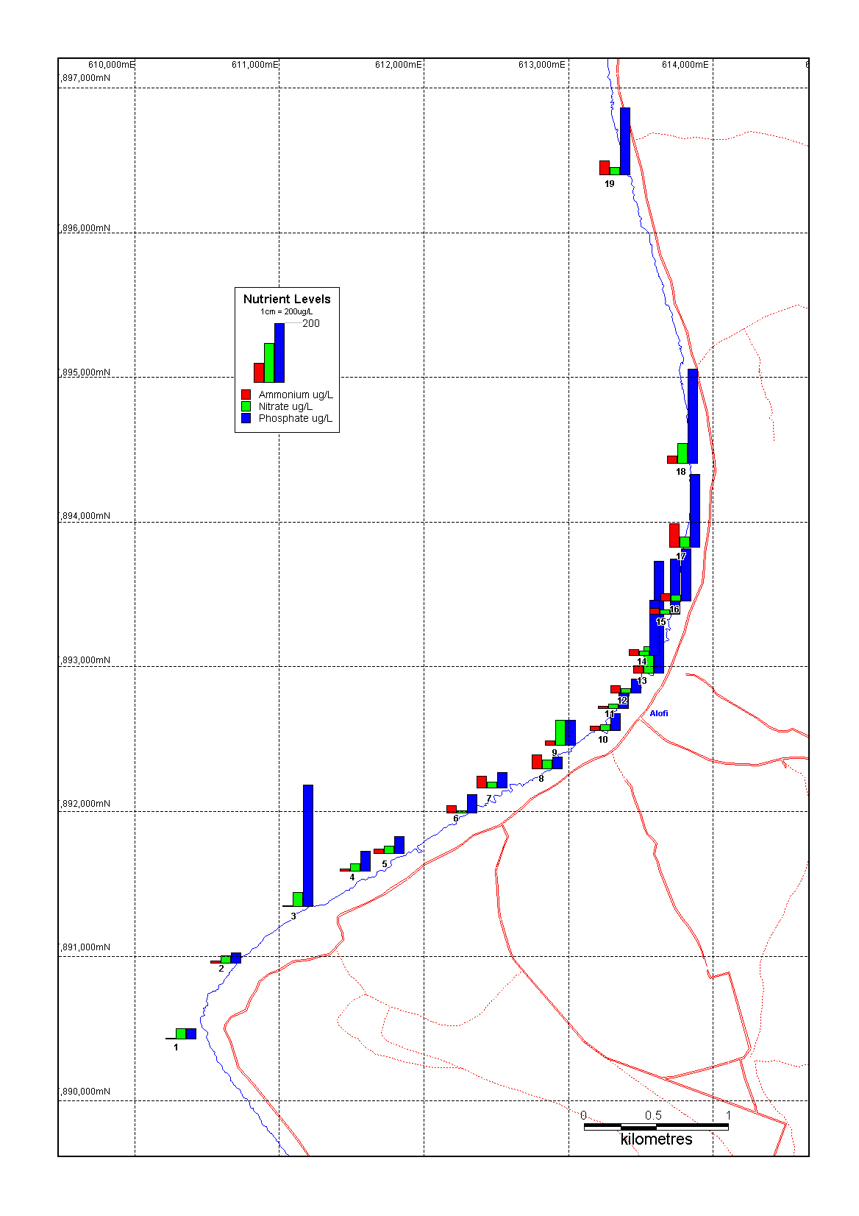

Figure 2: Map of nutrient concentrations in the Alofi Area
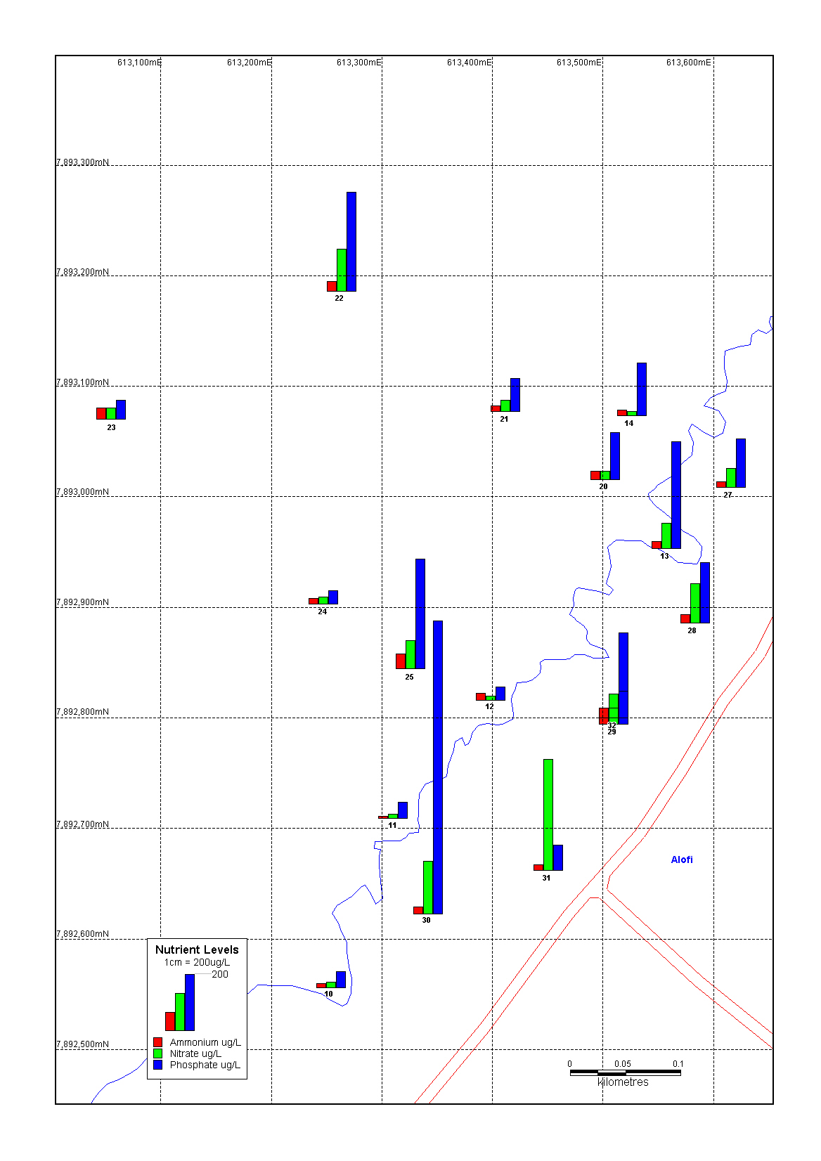

The finding of elevated nutrient levels is concerning as it may have helped in the establishment of algae and indirectly, Ciguatera-carrying dinoflagellates. Research on coral reefs in other locations has found that the levels of nutrients that may be considered healthy for coral reef ecosystems are approximately 1 μmol/L of N as nitrate or ammonia (14 μg/L N) and 0.1 μmol/L of P as orthophosphate and organophosphate (3 μg/L P) (Bell, 1992; Goreau and Thacker, 1994; ANZECC 2000) although there is some debate on this issue as excess nutrients can be uptaken by algae and removed from the water (Szmant, 2002). In any case, it is important to note that these levels are much lower than those which would be detrimental to any other aquatic ecosystem. Hence it is extremely important that coral reefs are protected from excess nutrient inputs.

The major sources of elevated nutrients to coastal waters are typically from human sewage waste and chemicals (e.g., detergents, fertilisers). Septic tanks are the predominant sanitation system on Niue but they do not remove much of the nutrient loading. The septic tanks discharge into soak pits or directly into the calcareous sand and rock materials in Niue. at most of the sites in the present study and the topsoil layer is typically thin. These porous type of soils/rock will provide little removal of nitrogen and phosphorus in the long-term. Typical calcium-containing United States sands will essentially exhaust there capacity to remove phosphorus in 3-6 months, after which only particulate-based organic phosphorus will be removed (USEPA 2002). Nitrogen removal is usually much poorer than phosphorus (USEPA 2002). Although ammonia is rapidly absorbed by soils the negatively charged nitrate ion is readily leached into groundwater (ANZECC 2000). Vegetation present will uptake a portion of the nutrients but if the amount of effluent sprayed onto land exceeds the rapid uptake capability of the plants, the nutrients are likely to be washed into the groundwater. Therefore groundwater inputs of nutrients to the coastline of Niue have likely led to these elevated nutrient levels being observed.

An integrated approach to coastal management is required to manage and control land-based sources of wastes before they enter the marine environment. Ideally, a municipal treatment plant and reticulation system should be installed with secondary treatment and nutrient removal systems (vegetation beds, wetlands, nitrification/denitrification units). Given that this is unlikely to happen in the near future, the focus should be on maintaining and improving existing systems.

Recommendations

- Regularly inspect and maintain existing sanitation systems.

Contamination of groundwater occurs when septic tanks fail because of poor maintenance (Dillion 1997). When septic tanks become full of sludge, the treatment time in the tank is reduced, the sewage can backflow if the perforated pipe becomes clogged, and continuous (rather than intermittent) seepage of effluent occurs. Septic tanks and pit latrines need to have sludge removed at intervals of between 2-10 years (depending on amount of usage). The sludge must also be disposed of properly and this should not be done in proximity to any water supply well. Sludge can be dried and incorporated with compost and spread (in thin amounts) over garden soils or under forests. Continuing communication to the local communities of the need for proper siting, construction and maintenance of septic tanks is required. Septic tank soak pits could be lined with cement, sand put in to filter the effluent, and vegetation (to uptake nutrients) planted on top. The use of composting toilet systems could also be trialled.

At the time of sampling, one septic tank from a Laundromat was observed to be overflowing down the side of the bank to the ocean. This is unacceptable and poses a health risk.

- Minimise reef degradation around the Port area of Alofi

It is important that the coral reef areas around Alofi are protected and maintained in good condition. Evidence already suggested that some degradation (dead and bleached corals, increased algal growth) has occurred (Yeeting 2002). Runoff of freshwater and silt from the wharf area is believed to be large at the moment as the concrete driveway and wharf area slopes directly down to the see with no water diversion on the upper portions. This should be more closely examined and attempted to be rectified. Ship ballast or bilge water should also not be discharged in the Alofi area. Bilge water may contain oil which could harm the coral while ballast water may contain foreign organisms, and this could have been the entry method for the latest outbreak of Ciguatera. Establishing more marine protected areas in the Alofi area would be beneficial to allow grazers to control algae which might harbour the Ciguatera organism.

- Funding should be obtained to conduct more water quality sampling and to train local personnel to conduct ongoing monitoring of the coastal water.

Further study is needed to confirm the results of the current study and ideally local capacity in water quality monitoring should be developed.

- Increasing the use of phosphate-free detergents would also a good option.

These types of detergents are readily available (e.g. from Johnson Diversey in New Zealand).

- A land and coastal management plan should be developed for the Alofi port area.

All stakeholders (e.g. Fisheries, Works, Environment departments) should be involved with the formulation and implantation of the plan.

Acknowledgements

Andre Siohane and Deve Talagi and from the Works Department for the excellent support and technical help. Fisheries Department for use of the boat and personnel for coastal sampling.

References

ANZECC (2000). Australian and New Zealand guidelines for fresh and marine water quality. Australian and New Zealand Environment and Conservation Council.

Bell, P., 1992. Eutrophication and coral reefs: some examples in the Great Barrier Reef lagoon. Water Research 26, 553-568.

Dalzell et al. (1993).

Goreau, T.J. and K. Thacker, 1994. Coral reefs, sewage, and wastewater quality standards. Proceedings, Caribbean Water and Wastewater Association Conference, Kingston, Jamaica.

Hodgson, G., 1999. A global assessment of human effects on coral reefs. Marine Pollution Bulletin 38, 345-355.

Jacobsen, G. and Hill, P.J. (1980). Hydrogeology of a raised coral atoll-Niue island. South Pacific Ocean. BMR Journ. Australian Geology and Geophysics? 5: 271-278.

Kinsey, D.W. and P.J. Davies, 1979. Effect of elevated nitrogen and phosphorus on a coral reef. Limnology and Oceanography 24, 935-940.

Kirkwood, D.S., 1994. Practical notes on the determination of nutrients in seawater. Skalar company publication.

Koop, K. and 19 others, 2001. ENCORE: The effect of nutrient enrichment on coral reefs. Synthesis of results and conclusions. Marine Pollution Bulletin 42, 91-120.

Marsh Jr., J.A., 1977. Terrestrial inputs of nitrogen and phosphorus on fringing reefs of Guam. Proceedings, 3rd International Coral Reef Symposium, 331-336.

McCook, L.J., 1999. Macroalgae, nutrients and phase shifts on coral reefs: scientific issues and management consequences for the Great Barrier Reef. Coral Reefs 18, 357-367.
McClanahan, T.R., 1997. Primary succession of coral-reef algae: Differing patterns on fished versus unfished reefs. Journal of Experimental Marine Biology and Ecology 218, 77-102.

Schaffelke, B., 1999. Short-term nutrient pulses as tools to assess responses of coral reef macroalgae to enhanced nutrient availability. Marine Ecology Progress Series 182, 305-310.

Szmant, A.M., 2002. Nutrient enrichment on coral reefs: is it a major cause of coral reef decline? Estuaries 25, 743-766.

Terry, J.P., Nunn, P.D. (2003). Interpreting features of carbonate geomorphology on Niue Island, a raised coral atoll. Z. Geomorph. N.F. Suppl. 131 43-57.

USEPA (2002). Onsite wastewater treatment systems manual. United States Environmental Protection Agency, Office of water. EPA/625/R-00/008.

Yeeting, B.M. (2003). A preliminary investigation of ciguatera fish poisoning in Niue.

Zann, L.P., 1994. The status of coral reefs in south western Pacific Islands. Marine Pollution Bulletin 29, 52-61.

